Plant Access
- Enter plant at the designated Employee entrance (door # 19) or (Contractors) gate F.
- At door #19, sign-in on visitor log and contact your company representative
- ID tag or armband must be always be visible and swiped at designated entrances.

Communication
In the event of an Emergency, listen to radios and/or overhead paging system. LLF employees will direct evacuation or shelter in place situations. In case of emergency call 3199 (Security), Channel 8 – Emergency channel, Channel 1 – Safety/Security or EHS manager 816-344-9973.

Meeting Points – See Evacuation maps posted at exit areas or department offices (zones A, B, C or D).

Check-in/Check-out – Upon entering LLF property, a LLF representative must be contacted before commencing work. Likewise, upon completion of work for the day, contact a LLF representative to review work and check-out.

Work Clothing
100% cotton, natural fiber, and/or FR rated in good repair are preferred (refer to your company policies or regulations). Sweat pants, sleeveless shirts, and sport shoes are not allowed.

Personal Protective Equipment (PPE)
At the minimum, bump-cap head protection, safety shoes, hair and/or beard nets, and safety glasses with sideshields shall be worn at all times within production areas (Corn Mill, Extruder, Elevator, Masa and Packaging). Hard hats may be required in designated construction areas. Follow GMP signs and wear beard nets (if applicable).

Hearing protection shall be worn in noisy environments. Additional PPE may be worn as required to provide protection from the hazards in the work environment.
Worker Responsibility
Immediately correct or report any unsafe work practices or conditions as they are observed.

Drug and Alcohol Free Work Site
Alcohol or other non-medically authorized drugs are prohibited on Company property. Narcotic medications are prohibited due to risks of equipment operations and working at elevated heights.

Tobacco-free
All tobacco products are prohibited on all Lifeline Foods property including parking lots. This includes electronic cigarettes.

Housekeeping - Work Area Cleanliness
Keep work areas clean and orderly at all times.
The job is not complete until the area is clean.

Injury / Illness
To summon emergency medical services contact the Security by dialing x 3199 or channel 8 on radios. Notify your crew leader in all cases involving injury or illness. Your crew leader should then notify EHS Manager for further analysis. First aid stations are located throughout our buildings and may be accessed as required. If you need a first aid kit while onsite, please contact EHS Manager.
Lockout/Tagout Procedure
All sources of hazardous energy must be controlled before equipment is worked on.
Locks and Tags are required for each authorized user when controlling energized sources. The Lockout/Tagout Procedure assures that the equipment is de-energized, isolated, tagged out, and verified before work begins.

Contractors should notify LLF EHS Manager their lock type and an example tag. If no locks are used, designated locks are available in our Maintenance dept along with Contractor specific LOTO tags. Never operate equipment that has a DANGER DO NOT OPERATE card or lock on it. Never remove Energy Securing Devices, tags or seals without authorization.

Hot Work
Hot Work permits are required prior to beginning work. Permits are good for the shift they are initiated on. Hot work includes drilling, grinding, welding, cutting, brazing and other operations that may create an ignition source. Fire extinguishers must be readily available at all hot work locations. Always maintain a safe distance from combustible material. Prevent sparks or slag from leaving the area. Use fire blankets when needed.

Check with LLF Company Representative or EHS Manager before performing any type of hot work to determine if a Hot Work Permit is required.
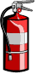Fires
If a fire is discovered immediately notify Security by dialing x3199. Inform Security of the level of assistance required. If it is safe to do so, extinguish small fires using a near-by extinguisher

Electrical Hazards
All electrical cords should be in good condition (unrepaired) and have GFCIs. Cords with missing ground prongs, cuts or temporary repairs shall not be used at any time.
Always observe the established minimum approach distance from unguarded, energized electrical equipment.

Fall Protection
If working 4’ or more above a working surface and appropriate guardrails are not in place, you must wear a fall protection harness and be tied off at all times. 3-ft Shock-absorbing lanyards or Self-retracting lifeline are preferred. Working on ladders requires 3-pts of contact, body within rails, avoid top two steps of step ladder, top 4 rungs of ladder. Scissor lifts do not require fall protection when working on platform. Aerial lift requires fall protection at all times.

Confined Space Entry
Anytime your work requires you to enter a confined space; you must contact Maintenance management or HSE Manager to obtain the proper Confined Space Entry Permit prior to entry.

Excavation Safety
Notify Maintenance management of your intention to construct an excavation so that proper procedures can be followed.

Hazard Communication
Contractors must provide SDSs for all hazardous chemicals brought onto the plant site to EHS manager prior to use.
For all onsite materials, SDSs are available electronically at MSDSOnline or in red SDS binders in various department offices throughout the plant. Contact EHS manager any time you are unsure about materials or substances you are working with.

Hazard Recognition
Use extra caution when handling or using acids, caustics, flammable, combustible, or toxic materials. Recognize and avoid unsafe conditions.
Eye Wash & Safety Showers
Identify the closest location to your work area. If eyes or skin are contaminated use shower/eye wash to thoroughly flush the affected area and contact EHS manager immediately.

Outside Activities
Anyone working on or near the Railyard and dock doors is required to wear hi-visibility garments (hats, vests, gloves, etc).

Chemical & Petroleum Spills
Immediately report any chemical or petroleum spill to EHS management that requires more than minor clean-up. If you can do so safely, direct the flow away from plant drains.

Questions
Feel free to ask our EHS or Security Manager any questions you may have about safety and security at any time.

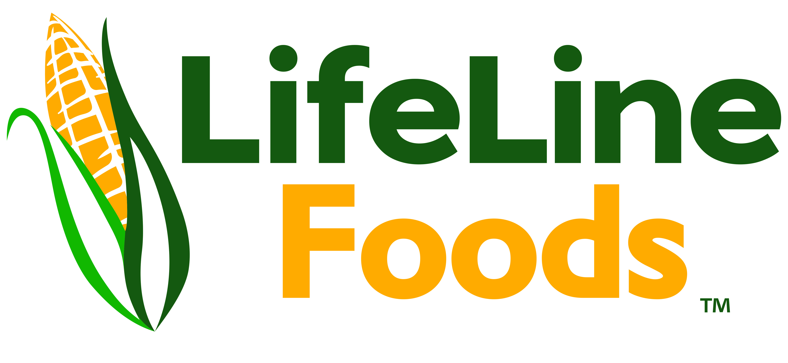

New Hire, Temp & Contractor Safety Information

Safety is everyone’s
responsibility!
See Something, Say Something, Stay Safe
Know the rules
Follow the rules

